CHAPTER-1
INTRODUCTION
The Enhanced Check-Post Clearance and Fast Track Monitoring System is concerned with the inter-state road permit activity i.e. in order to permit a vehicle to transport across the states. In order to get a permission to move across the states the owner of the respective vehicles has to get registered with their respective R.T.A’S to get permission to move across.
In order to maintain an interaction between different state R.T.A’S.The main role played here is by the CHECKMASTER who maintain a centralized database. The details of the vehicle’s and their respective owner detail’s are stored at their state R.T.A’S database whenever they register the vehicle by using a local database their process get’s updated in the centralized once.
The application software shall be menu & screen driven and will accept various parameters of the vehicles with data flowing from the gadgets installed at the check gate and shall generate the necessary fields to calculate the fines and other MIS reports for the revenue augmentation of the operations under guidelines from the RTA.
The proposed network shall have connectivity from remote locations to the data center.

CHAPTER-2

SYSTEM ANALYSIS

The Enhanced Check-Post Clearance and Fast Track Monitoring System is concerned with the inter-state road permit activity i.e in order to permit a vehicle to transport across the states. In order to get a permission to move across the states the owner of the respective vehicles has to get registered with their respective R.T.A’S to get permission to move across.

Respective state R.T.A’S have their own database of their people’s details and vehicle details. As there is no interaction between the different R.T.A’S of different states it is necessary to maintain a centralized database for the purpose of differentiating between the vehicles passing by are of which state.

In order to maintain an interaction between different state R.T.A’S.The main role played here is by the CHECKMASTER who maintain a centralized database. The details of the vehicle’s and their respective owner detail’s are stored at their state R.T.A’S database whenever they register the vehicle by using a local database their process get’s updated in the centralized once.

2.1 EXISTING SYSTEM

As per now, no state has a central check post management and even though some places has one, it’s been used only to see the weigh bridge known as the weigh bridge check post systems.
The project was conceived with the intention to computerize all the check posts of regional transport office (RTO) for checking the over weight of commercial vehicles. The existing system has to collect all the details pertaining to all commercial vehicles of that place and also vehicles from the neighboring states. The data of each and every vehicle will be updated at the check post level whenever a transaction takes place.

2.2 PROPOSED SYSTEM

The proposed system will have a system like Integrated check post where the details of each and every vehicle and the respective owner will be maintained centrally. So whenever a vehicle visits a check post the registration number will allow you to know the entire data of particular vehicle / owner. The Registration, Permits and License details will be maintained in the centralized server which the authorities can see according to the access they have been provided.
The projects intention is to reduce the man power, work load and the most important constraint “TIME”.

2.3 FEASIBILITY REPORT
Preliminary investigation examine project feasibility, the likelihood the system will be useful to the organization. The main objective of the feasibility study is to test the Technical, Operational and Economical feasibility for adding new modules and debugging old running system.

Types of feasibility:
- Technical Feasibility
- Operation Feasibility
- Economical Feasibility

2.3.1 Technical Feasibility
The technical issue usually raised during the feasibility stage of the investigation includes the following:
- The proposed equipments have the technical capacity to hold the data required to use the new system.
- The proposed system provides adequate response to inquiries, regardless of the number or location of users.

2.3.2 Operational Feasibility

Proposed projects are beneficial only if they can be turned out into information system. That will meet the organization’s operating requirements. Operational feasibility aspects of the project are to be taken as an important part of the project implementation.

2.3.3 Economic Feasibility

A system can be developed technically and that will be used if installed must still be a good investment for the organization. In the economical feasibility, the development cost in creating the system is evaluated against the ultimate benefit derived from the new systems. Financial benefits must equal or exceed the costs.

2.4 PROJECT OVERVIEW

Check post computerization is a process of reducing user’s manual work and paper work gradually reducing the time to check the vehicles at inter-state borders.

The process of registration for a vehicle starts as the owner of the vehicle first need to apply online after registration of his motor vehicle will be provided by a registration number, the number is unique and it is the vehicle number after completion of registration the detailed information is maintained in the server. The information of all the vehicles is registered at RTA servers.

After completion of motor vehicle registration the owner of the motor vehicle takes the vehicle to RTA. The sequence of all the manual examinations after passing each phase of examinations the motor vehicle is given a certificate of fitness. The fitness of vehicle information is maintained in the server, if the motor vehicle fails any examination it will not be given the certificate of fitness of transport vehicle.

After completion of the issuing of fitness of motor vehicle the owner has to apply for no objection certificates. They are issued for motor vehicles when the motor vehicle taxes are paid to the government and RTO approves the motor vehicle for state to state moment certificate. The no objection certificates also include the weight of the motor vehicle can carry to transport. So the no objection certificate is issued only if you clear your road taxes, insurance and other formalities. The details of the no objection certificate are also maintained in the server of RTA.

Issue of license to the driver of motor vehicle is next phase. In this phase the driver need to prove that he is capable of driving the motor vehicle and he need to present it in front of RTO to acquire the driving license for specified motor vehicle (6,10 etc.,). After issue of license to driver of motor vehicle the detailed information of the driving license is maintained in server of RTA.

After completion of driving license issue the owner of the motor vehicle apply for the permit issue, here the owner of the motor vehicle select the type of permit he want for the motor vehicle (permit like national, interstate, with in state) or he can select the state he want to get permit. After issue of the permit to the motor vehicle the detailed information of the motor vehicle permit are maintained in the server of RTA.

Registration validity is a phase which is performed when the motor vehicle wants to transport goods from one state to other state at interstate check post here the vehicle number is entered and then check motor vehicles details. The person at check post check’s whether the motor vehicle registration is valid or not. If he is not eligible to cross the border and still tried to cross the check post then he has to pay penalty to the officers of the concerned authority as per the given government laws.

After completion of registration validity check the motor vehicle under goes another check called driving license validity. In this phase the driver’s license is checked if it’s not renewed the penalty has to be paid by the driver and he won’t be permitted as per the governing laws.

After completion of driving license validity the motor vehicle undergoes another phase called permit validity. In this phase “weighbridge” is seen and if a vehicle is carrying more weight than the usual weight which is specified by the law then the vehicle can get penalty and he won’t be allowed to cross the check post in addition to taking the license away. The permit information is retrieved from the RTA server. The person at the check post checks the permit details and other information related to vehicle if all are in correct order and as per government rules the motor vehicle is allowed to transport and permission is given to enter the other state. Else, it will be rejected and permission will not be given the permit to transport and in addition penalty will be filed on the vehicle.

Project Modules:

- Registration of vehicle
- Issue of no objection certificate
- Issue of certificate of vehicle fitness
- Issue of license to driver of motor vehicle
- Issue of permits
- Registration validation
- Driving license validity
- Permit validity

Registration of motor vehicle
Each and every vehicle has to get registered by their respective R.T.A’S to get permitted to travel on roads. In order to get registered the owner’s have to provide few detail’s to be entered in the register form such as, vehicle owner name, owner address, engine number,color,month and year of manufactured, maker’s classification, type of vehicle, seating capacity, photo image, finger prints etc

Issue of no objection certificate
After getting registered by their respective R.T.A’S which indeed gets transferred to the centralized database. Each and every vehicle by getting registered by their respective R.T.A’S in order to differentiate between the legalized transporter’s and non-legalized once.
By entering their unique registration details and also the registration validity issue and expiry detail’s one can get a no objection certificate. Here the registration validity can also be renewed.

Issue of certificate of fitness of transport vehicles
Based on the fitness of the vehicle they get a fitness certificate issued by the central government. In order to get a fitness certificate they have to satisfy few conditions’ provided by the government such as pollution check issued and expiry date, road tax details, insurance details such as issue and expiry and also the condition of the vehicle such as functioning of brakes and engine details etc.

Issue of license to driver of motor vehicle
On the basis of the details furnished by the furnisher such as address proof’s, personal details such as blood group, date of birth and application for type of vehicle or etc,insurance certificate,R.C,pollution check control of the vehicle already registered or etc.
Based on his/her details furnished the respective state R.T.A’S gives an unique license number to the details furnisher by crosschecking the driving skills.

Issue of permits
In this module based on the details provided by the vehicle owner regarding the details of the license, vehicle pollution check certificate, vehicle fitness certificate, the permissions are given to stage carriers i.e. buses, for contract carriers(as taxes and contracted vehicles)and also for goods carriages permits.
Once a vehicle gets permission certificate then it can be allowed to travel across the states. After processing all the details R.T.A’S of respective states gives the validity tenure i.e issue and expiry dates and these details gets updated to the central database.
In case of goods carriers like trucks the weigh load is calculated before the movement from one state to another. Depending upon its vehicle structure the weight permits assigned. Whenever it is over weighed than suggested weight he should be penalized and the date and time of the penalty is maintained. And the different types of penalties are charged for offending the government rules.

Registration validity
By the details provided by the vehicle owner during registration such as personal details and vehicle details, one can confirm that his/her registration is valid when we get a registration validity tenure i.e. issue and expiry date and by cross checking the present registration is within the tenure or not if else they are penalized based on the rules/sections provided according to the government act.
If they fail in the registration validity the owner can renew their validity at the R.T.A’S and the updates are again resembled at the central database.

Driving license validity
On furnishing the details for the license by the furnisher, on account of the legal documentation verification the R.T.A’S provide a validity of license for a particular tenure i.e. issue date and expiry date and a license number along with license holder name, address.
Based on the above details and also the validity of the license they are given permission to move across the check post of different states and once their validity duration gets expired it has to be renewed or else they are penalized.

Permit validity
In this module, one has to enter the permit issued date and expiry date, the name of the permit holder, also the permit type whether it is a stage carrier or goods carrier or etc and also they cross check the permit weight of the respective permit details in order to cross check or verify whether he/she have got a valid permit or not or else they are fined according to their offence.

2.5 REQUIREMENTS SPECIFICATIONS
2.5.1 Software requirements
Operating System : Windows XP Service Pack 2
Technology : java
Web Server : Apache Tomcat
Database : oracle 10g

2.5.2 Hardware Requirements
Hardware : Pentium based system with a minimum of P4
RAM : 256(MINIMUM)

2.4 Functional Requirements:-

The main purpose of functional requirements within the requirement specification document is to define all the activities or operations that take place in the system. These are derived through interactions with the users of the system.

Administrator:
- Admin can login into this application.
- Admin can add the new employees for all districts in RTA offices.
- Admin can change his password.

Employee:
- Employee can book the vehicle Registration slot.
- Employee can validate the vehicle registration.
- Employee can do the vehicle transfer.
- Employee can issue the NOC certificate.
- Employee can issue the Fitness certificate.
- Employee can book the driving license slot.
- Employee can issue the driving license certificate.
- Employee can transfer the driving license.
- Employee can issue the vehicle root permit.
- Employee can change his password.

Customer:
- Customer can apply for vehicle registration.
- Customer can view the vehicle registration.
- Customer can apply for NOC certificate.
- Customer can apply for Fitness certificate.
- Customer can view Fitness certificate.
- Customer can apply for Driving License certificate.
- Customer can view Driving License certificate.
- Customer can apply for root permit certificate.
- Customer can view root permit certificate.
- Customer can change his password.

Check Post Employee:
- Check Post Employee can check the vehicle registration certificate validation.
- Check Post Employee can check the vehicle fitness certificate validation.
- Check Post Employee can check the driving license certificate validation.
- Check Post Employee can check the vehicle NOC certificate validation.
- Check Post Employee can check the vehicle root permit certificate validation.
- Check Post Employee can calculate the penalty for vehicle.
- Check Post Employee can generate the penalty reports for vehicle.

2.5 Non-functional requirements:

Nonfunctional requirements describe user-visible aspects of the system that are not directly related to functionality of the system.
User Interface and Human factors:
The proposed system should provide a user- friendly interface to customers and Employees as well as Administrator with ease of use. The user interface must be suitable for easy and fast data entry. With the help of this interface, customers and Employees even without adequate knowledge of systems would complete their tasks. Users needs little training about the system in-order to utilize the facilities being provided by the system efficiently.

Documentation:
The proposed system requires three levels of documentation, user level documentation which helps the customers, employees and administrator how to interact with the system. This documentation includes how to fill the forms provided and get reports that can be generated by the system. In the proposed system help link provides the user level documentation. The RAD prepared during analysis phase helps the developer in-order to develop the system as per client’s requirements. The system design documentation prepared during development process provides information regarding design goals and about subsystems into the proposed system which also helps in testing process. In addition to user level and development level documentation proposed system also requires technical documentation for maintainers of the system. This technical documentation includes the port number on which server is running and listening clients requests and also includes any other configuration required for maintainers.

Hardware Consideration:
Hardware Considerations includes the virtual machine on which the system should be built. Virtual machine includes operating system and any software components needed. Virtual machine minimum required for web server is WINDOWS xp system and web browser is IE 6.0.And the system is compatible with Linux, Unix based systems.

Performance Characteristics:
The proposed system is server applications and server applications are inherently multi-threaded. Every request creates new thread hence the system supports any no’ of concurrent users. Hence this system offers good performance and easy solutions to problems. This is the static requirement. The Dynamic requirement is system response. As the proposed system developed using JavaServerPages which reduces response problems.

Error handling and Extreme conditions:
The proposed system should handle exceptions that originate at low level components and exceptions at high level components. The high level components in proposed system should handle exceptions that occur while connecting to database server, IOExceptions etc. The end user should not be bother about exceptions at low-level. When low level Exceptions arises user should be shown with appropriate message. Errors that arises during data entry should be handled by performing client side validations. In the proposed system all client side validations will be done using JavaScript.

Quality Issues:
Quality issues refers to how reliable and robust should the system be? While developing the proposed system the developer must be able to guarantee the reliability transactions so that they will be processed completely and accurately.
The ability of system to detect failures and recovery from those failures refers to the availability of system. Robustness of system refers to the capability of system providing information when concurrent users requesting for information.
As the proposed system’s capability of handling various exception it is reliable and it will be developed using JSP which supports multithreading. Hence it satisfies the requests from concurrent users. So it is robust.

System modification:
As the proposed is not implementing online payments for penalty’s so it can be extended and this updating can be done by any developer familiar with specified hardware and software constraints followed for development of proposed system.

Security Issues:
Security and confidentiality are the top most concerns of the client. The proposed system should provide the following.
- Administrator should be provided with id and password for secured access of information regarding employees and customers.
- Each Customer should also be provided with code and password for controlled access of information regarding their applications.
- Each employee should be provides with a username and password

CHAPTER-3

SYSTEM DESIGN

3.1 UML Diagrams:-

UML stands for Unified Modeling Language. UML is a language for specifying, visualizing and documenting the system. This is the step while developing any product after analysis. The goal from this is to produce a model of the entities involved in the project which later need to be built. The representation of the entities that are to be used in the product being developed need to be designed.

There are various kinds of methods in software design:

They are as follows:
- Use case Diagram
- Sequence Diagram
- Class Diagram
- Activity Diagram

3.1.1 Class Diagram
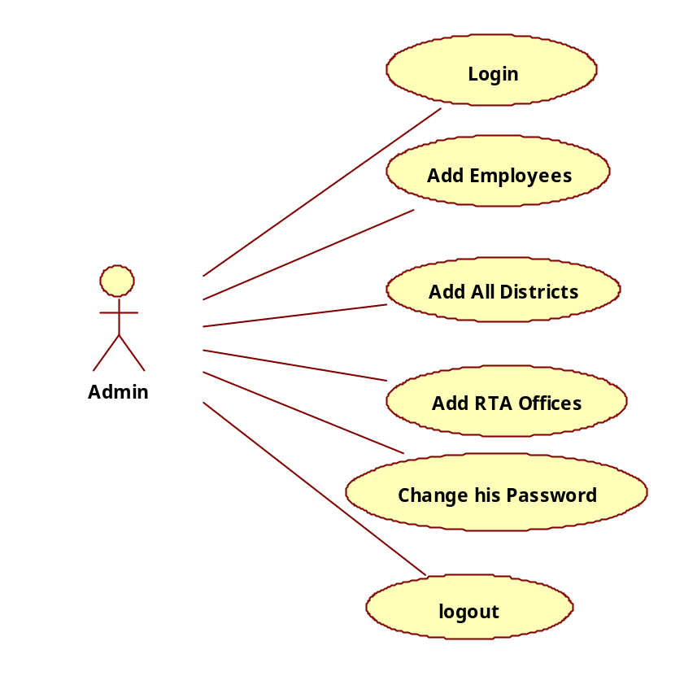
Fig: USE CASE Diagram for Admin

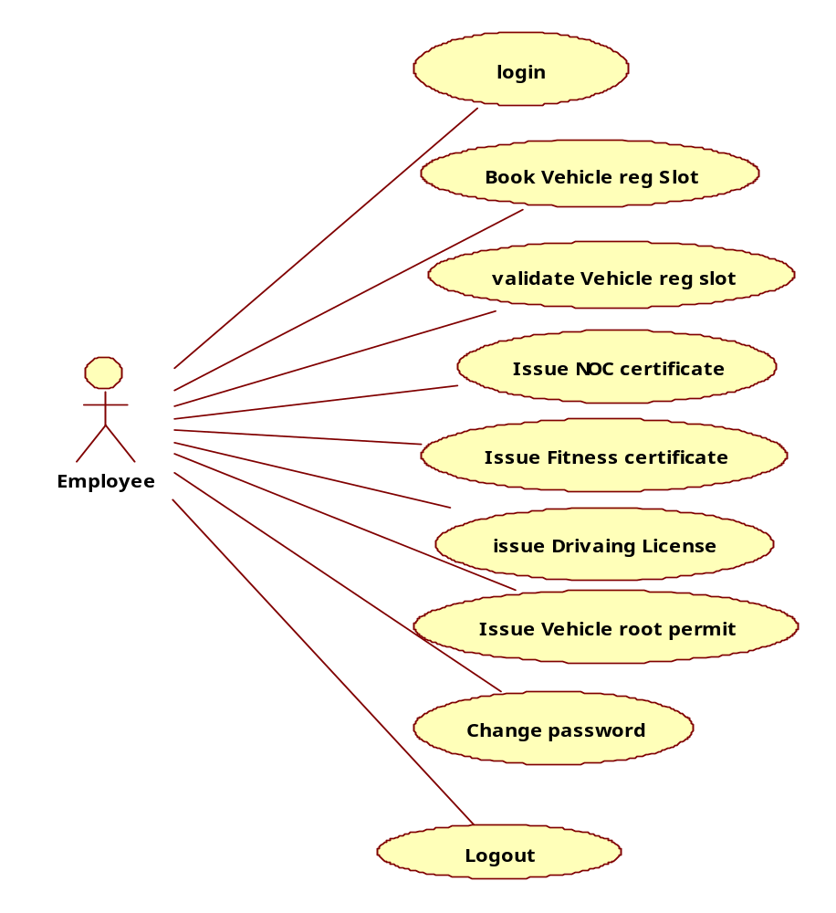
Fig: USE-CASE Diagram for Employee

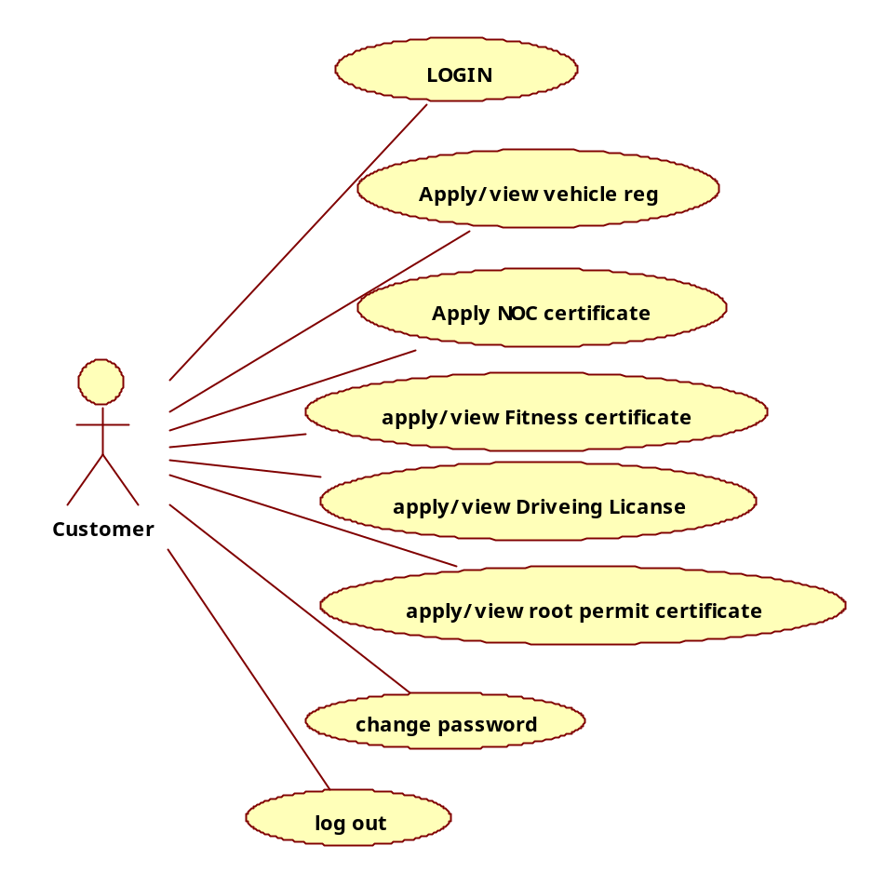
Fig: USE-CASE Diagram for Customer

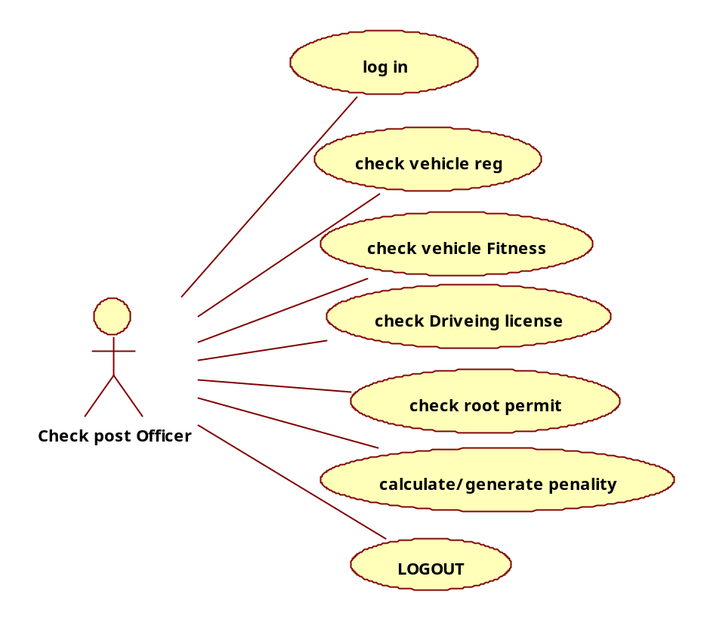
Fig: USE-CASE Diagram for Check post Officer

3.1.2 Use Case Diagram
A Use case is a description of set of sequence of actions. Graphically it is rendered as an ellipse with solid line including only its name. Use case diagram is a behavioral diagram that shows a set of use cases and actors and their relationship. It is an association between the use cases and actors. An actor represents a real-world object. Primary Actor–Sender, Secondary Actor Receiver.

3.1.3 Sequence Diagram
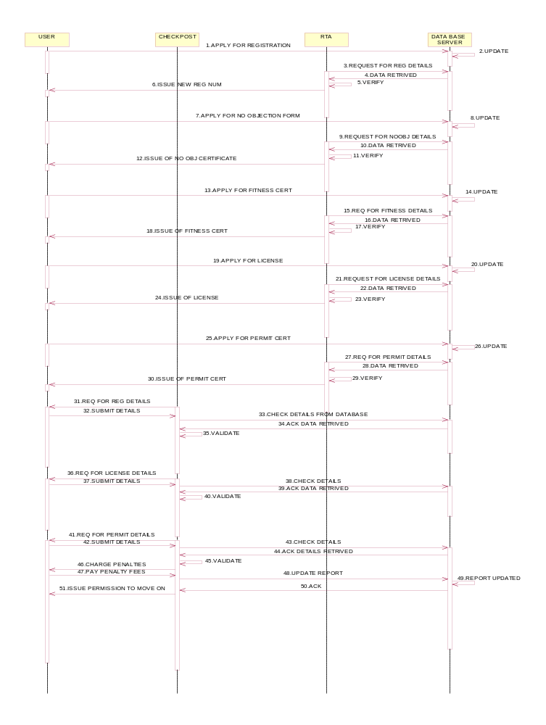
Figure: 3.4 Sequence Diagram of check-post

3.1.4 Activity Diagram:-
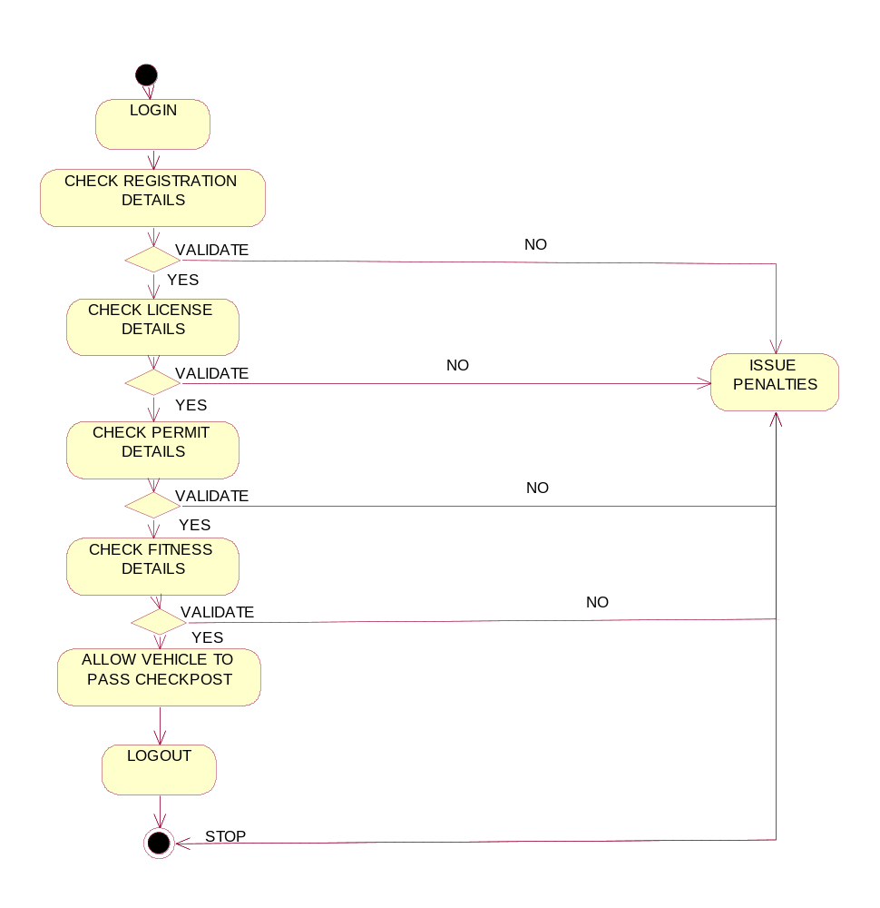

Figure: 3.4 Activity Diagram of check-post

3.1.5 Class Diagram:-

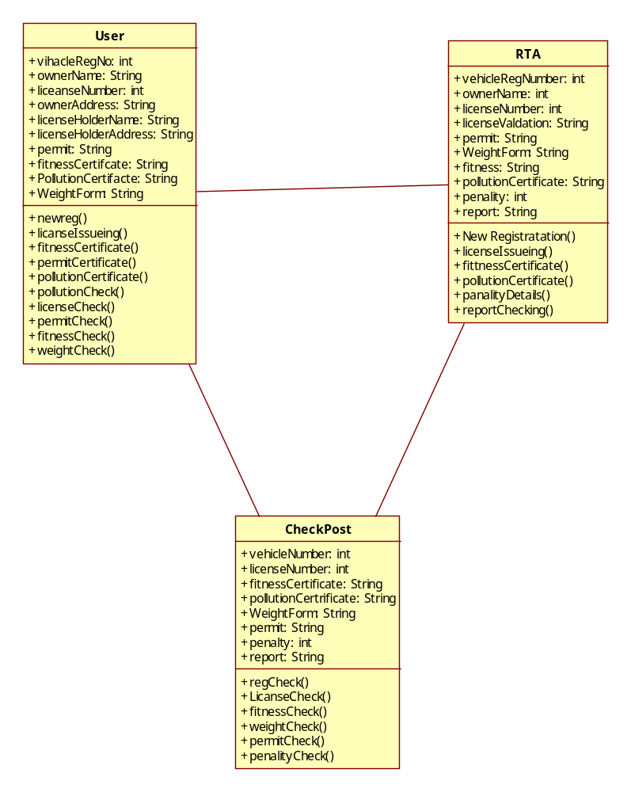
Figure: 3.4 Class Diagram of check-post

3.2 DATABASE DESIGN

Table Name: Applyfittness
Column Name | Data Type | Nullable | Default | Primary Key
ID | NUMBER | No | - | 1
REG_ID | NUMBER | Yes | - | -
STATUS | VARCHAR2(100) | Yes | 'OPEN' | -
BREAKS_VALID | VARCHAR2(30) | Yes | - | -
POLUTION_VALID | VARCHAR2(30) | Yes | - | -
CONDITION_VALID | VARCHAR2(30) | Yes | - | -
COND_REJECT_DETAILS | VARCHAR2(4000) | Yes | - | -
EMP_ID | NUMBER | Yes | - | -
VALID_FROM | DATE | Yes | - | -
VALID_TO | DATE | Yes | - | -
PRINT_MATTER | VARCHAR2(4000) | Yes | - | -
CUST_ID | NUMBER | Yes | - | -
REG_VALID | VARCHAR2(30) | Yes | - | -

Table Name: APPLYNOC

Column Name | Data Type | Nullable | Default | Primary Key
ID | NUMBER | No | - | 1
REG_ID | NUMBER | Yes | - | -
STATUS | VARCHAR2(100) | Yes | 'OPEN' | -
CUST_ID | NUMBER | Yes | - | -
REG_VALID | VARCHAR2(20) | Yes | - | -
TAX_PAID | VARCHAR2(20) | Yes | - | -
ANY_CASE | VARCHAR2(20) | Yes | - | -
CASE_DETAILS | VARCHAR2(4000) | Yes | - | -
EMP_ID | NUMBER | Yes | - | -
VALID_FROM | DATE | Yes | - | -
VALID_TO | DATE | Yes | - | -
PRINT_MATTER | VARCHAR2(4000) | Yes | - | -

Table Name: customer

Column Name | Data Type | Nullable | Default | Primary Key
CUST_ID | NUMBER | No | - | 1
NAME | VARCHAR2(100) | Yes | - | -
USERID | VARCHAR2(100) | Yes | - | -
PASSWORD | VARCHAR2(100) | Yes | - | -
MOBILE | VARCHAR2(12) | Yes | - | -
PHONE | VARCHAR2(12) | Yes | - | -
ADDRESS | VARCHAR2(100) | Yes | - | -
EMAIL | VARCHAR2(100) | Yes | - | -
CREATEDON | TIMESTAMP(6) | Yes | - | -

Table Name: dist

Column Name | Data Type | Nullable | Default | Primary Key
DISTID | NUMBER | No | - | 1
NAME | VARCHAR2(100) | Yes | - | -

Table Name: DRIVING_LICENSE

Column Name | Data Type | Nullable | Default | Primary Key
ID | NUMBER | No | - | 1
DLID | VARCHAR2(100) | Yes | '0' | -
VALID_FROM | DATE | Yes | - | -
VALID_TO | DATE | Yes | - | -
NAME | VARCHAR2(1000) | Yes | - | -
DOB | DATE | Yes | - | -
BLOOD_GROUP | VARCHAR2(10) | Yes | - | -
ADDRESS | VARCHAR2(4000) | Yes | - | -
LIC_AUTHORITY | VARCHAR2(1000) | Yes | - | -
EMP_ID | NUMBER | Yes | - | -
PROOF_AGE | VARCHAR2(100) | Yes | - | -
PROOF_RESIDENCE | VARCHAR2(1000) | Yes | - | -
PHYSICAL_FITNESS | VARCHAR2(100) | Yes | - | -
MEDICAL_CERT | VARCHAR2(100) | Yes | - | -
CUST_ID | NUMBER | Yes | - | -
REJECT_REASON | VARCHAR2(4000) | Yes | - | -
STATUS | VARCHAR2(100) | Yes | 'OPEN' | -
COUNTRY | VARCHAR2(100) | Yes | - | -
STATE | VARCHAR2(100) | Yes | - | -
DISTID | NUMBER | Yes | - | -
MANDALID | NUMBER | Yes | - | -
CREATED_ON | TIMESTAMP(6) | Yes | - | -
PHOTO_PATH | VARCHAR2(4000) | Yes | - | -

Table Name: DRIVING_SLOT

Column Name | Data Type | Nullable | Default | Primary Key
ID | NUMBER | No | - | 1
SLOT_DATE | DATE | Yes | - | -
SLOT_TIME | VARCHAR2(30) | Yes | - | -
DRIVE_ID | NUMBER | Yes | - | -
EMP_ID | NUMBER | Yes | - | -
STATUS | VARCHAR2(100) | Yes | 'OPEN' | -
REASON | VARCHAR2(4000) | Yes | - | -
CREATED_ON | DATE | Yes | - | -

Table Name: EMPAUTHORIZATION

Column Name | Data Type | Nullable | Default | Primary Key
USER_ID | VARCHAR2(4000) | No | - | 1
USER_NAME | VARCHAR2(4000) | Yes | - | -
PASSWORD | VARCHAR2(4000) | Yes | - | -
CONFIRM_PASS | VARCHAR2(4000) | Yes | - | -
ROLE | VARCHAR2(4000) | Yes | - | -

Table Name: EMPLOYEE

Column Name | Data Type | Nullable | Default | Primary Key
ID | NUMBER | No | - | 1
NAME | VARCHAR2(100) | Yes | - | -
PASSWORD | VARCHAR2(100) | Yes | - | -
ROLE | VARCHAR2(100) | Yes | 'MANAGER' | -
DISTID | NUMBER | Yes | 0 | -
MANDALID | NUMBER | Yes | 0 | -
USERID | VARCHAR2(100) | Yes | - | -
CREATED_ON | TIMESTAMP(6) | Yes | - | -

Table Name: FITVALIDATION

Column Name | Data Type | Nullable | Default | Primary Key
REG_NO | VARCHAR2(4000) | Yes | - | -
NAME | VARCHAR2(4000) | Yes | - | -
ADDR | VARCHAR2(4000) | Yes | - | -
DOB | VARCHAR2(4000) | Yes | - | -
ENGIN_NO | VARCHAR2(4000) | Yes | - | -
FITNESS_ISSUE_DATE | VARCHAR2(4000) | Yes | - | -
REG_YEAR | VARCHAR2(4000) | Yes | - | -
FITNESS_EXPIRY | VARCHAR2(4000) | Yes | - | -
BREAK_WORKING | VARCHAR2(4000) | Yes | - | -
POLLUTION_FREE | VARCHAR2(4000) | Yes | - | -

Table Name: LICEVALIDATION

Column Name | Data Type | Nullable | Default | Primary Key
LICENSE_ID | VARCHAR2(4000) | Yes | - | -
NAME | VARCHAR2(4000) | Yes | - | -
SON_WIFE_DAUGHTER_OF | VARCHAR2(4000) | Yes | - | -
ADDR | VARCHAR2(4000) | Yes | - | -
DOB | VARCHAR2(4000) | Yes | - | -
BLOOD_GROUP | VARCHAR2(4000) | Yes | - | -
VALID_FROM | VARCHAR2(4000) | Yes | - | -
VALID_UPTO | VARCHAR2(4000) | Yes | - | -
TYPE_OF_VEHICLE | VARCHAR2(4000) | Yes | - | -

Table Name: MANDAL
Column Name | Data Type | Nullable | Default | Primary Key
MANDALID | NUMBER | No | - | 1
DISTID | NUMBER | Yes | - | -
NAME | VARCHAR2(100) | Yes | - | -
CODE | VARCHAR2(10) | Yes | - | -
ADDRESS | VARCHAR2(100) | Yes | - | -

Table Name: NATIONAL_PERMIT

Column Name | Data Type | Nullable | Default | Primary Key
ID | NUMBER | No | - | 1
REG_ID | NUMBER | Yes | - | -
VALID_FROM | DATE | Yes | - | -
VALID_TO | DATE | Yes | - | -
PRINT_MATTER | VARCHAR2(4000) | Yes | - | -
STATUS | VARCHAR2(100) | Yes | 'OPEN' | -
CARRY_WEIGHT | VARCHAR2(1000) | Yes | - | -
REJECT_STATUS | VARCHAR2(100) | Yes | - | -
REJECT_DESC | VARCHAR2(4000) | Yes | - | -
EMP_ID | NUMBER | Yes | - | -
CUST_ID | NUMBER | Yes | - | -
NOC_CLEAR | VARCHAR2(30) | Yes | - | -
FITNESS_CLEAR | VARCHAR2(30) | Yes | - | -
CREATED_ON | TIMESTAMP(6) | Yes | - | -
STATE_NAME | VARCHAR2(100) | Yes | - | -

Table Name: NOCVALIDATION

Column Name | Data Type | Nullable | Default | Primary Key
REG_NO | VARCHAR2(4000) | Yes | - | -
NAME | VARCHAR2(4000) | Yes | - | -
ADDR | VARCHAR2(4000) | Yes | - | -
CLASS_OF_VEHICLE | VARCHAR2(4000) | Yes | - | -
ENGIN_NO | VARCHAR2(4000) | Yes | - | -
CHASIS_NO | VARCHAR2(4000) | Yes | - | -
ANY_THEFT_CASE | VARCHAR2(4000) | Yes | - | -
TAX_PENDING | VARCHAR2(4000) | Yes | - | -
ISSUED_DATE | VARCHAR2(4000) | Yes | - | -

Table Name: PERMITVALIDATION

Column Name | Data Type | Nullable | Default | Primary Key
REG_NO | VARCHAR2(4000) | Yes | - | -
NAME | VARCHAR2(4000) | Yes | - | -
ADDR | VARCHAR2(4000) | Yes | - | -
VEHICLE_DESCRIPTION | VARCHAR2(4000) | Yes | - | -
VALID_FROM | VARCHAR2(4000) | Yes | - | -
VALID_UPTO | VARCHAR2(4000) | Yes | - | -
ALLOWED_WEIGHT | VARCHAR2(4000) | Yes | - | -

Table Name: REGVALIDATION

Column Name | Data Type | Nullable | Default | Primary Key
REG_NO | VARCHAR2(4000) | Yes | - | -
NAME | VARCHAR2(4000) | Yes | - | -
AGE | VARCHAR2(4000) | Yes | - | -
ADDR | VARCHAR2(4000) | Yes | - | -
CLASS_OF_VEHICLE | VARCHAR2(4000) | Yes | - | -
TYPE_OF_BODY | VARCHAR2(4000) | Yes | - | -
REG_DATE | VARCHAR2(4000) | Yes | - | -
COLOR | VARCHAR2(4000) | Yes | - | -
TYPE_VEHICLE | VARCHAR2(4000) | Yes | - | -
CHASIS_NO | VARCHAR2(4000) | Yes | - | -
ENGIN_NO | VARCHAR2(4000) | Yes | - | -
NATIONALITY | VARCHAR2(4000) | Yes | - | -

Table Name: REG_VEHICLE

Column Name | Data Type | Nullable | Default | Primary Key
ID | NUMBER | No | - | 1
REG_NO | VARCHAR2(100) | Yes | '0' | -
OWNER_NAME | VARCHAR2(100) | Yes | - | -
ADDRESS | VARCHAR2(100) | Yes | - | -
ENG_NO | VARCHAR2(100) | Yes | - | -
CHASIS_NO | VARCHAR2(100) | Yes | - | -
BODY | VARCHAR2(100) | Yes | - | -
COLOR | VARCHAR2(100) | Yes | - | -
BRAND | VARCHAR2(100) | Yes | - | -
CC | VARCHAR2(100) | Yes | - | -
NOOFSEATS | NUMBER | Yes | - | -
BIKE_NAME | VARCHAR2(100) | Yes | - | -
DISTID | NUMBER | Yes | - | -
MANDALID | NUMBER | Yes | - | -
STATE | VARCHAR2(100) | Yes | - | -
COUNTRY | VARCHAR2(100) | Yes | - | -
CREATED_ON | TIMESTAMP(6) | Yes | - | -
MANU_MONTH | VARCHAR2(2) | Yes | - | -
MANU_YEAR | VARCHAR2(4) | Yes | - | -
CUST_ID | NUMBER | Yes | - | -

Table Name: REG_VEHICLE_VALID

Column Name | Data Type | Nullable | Default | Primary Key
ID | NUMBER | No | - | 1
VALID_FROM | DATE | Yes | - | -
VALID_TO | DATE | Yes | - | -
REG_ID | VARCHAR2(100) | Yes | - | -
STATUS | NUMBER | Yes | 0 | -
EMP_ID | NUMBER | Yes | - | -
PHOTO_PATH | VARCHAR2(4000) | Yes | - | -
CREATED_ON | TIMESTAMP(6) | Yes | - | -

Table Name: SLOT

Column Name | Data Type | Nullable | Default | Primary Key
ID | NUMBER | No | - | 1
SLOT_DATE | DATE | Yes | - | -
SLOT_TIME | VARCHAR2(10) | Yes | - | -
REG_ID | NUMBER | Yes | - | -
EMP_ID | NUMBER | Yes | - | -
CREATED_ON | TIMESTAMP(6) | Yes | - | -
FLAG | NUMBER | Yes | 0 | -
STATUS | VARCHAR2(100) | Yes | - | -

CHAPTER-4
IMPLEMENTATION

4.1 TECHNOLOGY

Front End Technology

4.1.1 Java Technology
Initially the language was called as “oak” but it was renamed as “Java” in 1995. The primary motivation of this language was the need for a platform-independent (i.e., architecture neutral) language that could be used to create software to be embedded in various consumer electronic devices.
- Java is a programmer’s language.
- Java is cohesive and consistent.
- Except for those constraints imposed by the Internet environment, Java gives the programmer, full control.
- Finally, Java is to Internet programming where C was to system programming.

Importance of Java to the Internet
Java has had a profound effect on the Internet. This is because; Java expands the Universe of objects that can move about freely in Cyberspace. In a network, two categories of objects are transmitted between the Server and the Personal computer. They are: Passive information and Dynamic active programs. The Dynamic, Self-executing programs cause serious problems in the areas of Security and probability. But, Java addresses those concerns and by doing so, has opened the door to an exciting new form of program called the Applet.

Java can be used to create two types of programs: Applications and Applets:
An application is a program that runs on our Computer under the operating system of that computer. It is more or less like one creating using C or C++. Java’s ability to create Applets makes it important. An Applet is an application designed to be transmitted over the Internet and executed by a Java –compatible web browser. An applet is actually a tiny Java program, dynamically downloaded across the network, just like an image. But the difference is, it is an intelligent program, not just a media file. It can react to the user input and dynamically change.
Features of Java Security
Every time you that you download a “normal” program, you are risking a viral infection. Prior to Java, most users did not download executable programs frequently, and those who did scan them for viruses prior to execution. Most users still worried about the possibility of infecting their systems with a virus. In addition, another type of malicious program exists that must be guarded against. This type of program can gather private information, such as credit card numbers, bank account balances, and passwords. Java answers both these concerns by providing a “firewall” between a network application and your computer. When you use a Java-compatible Web browser, you can safely download Java applets without fear of virus infection or malicious intent.

Portability

For programs to be dynamically downloaded to all the various types of platforms connected to the Internet, some means of generating portable executable code is needed .As you will see, the same mechanism that helps ensure security also helps create portability. Indeed, Java’s solution to these two problems is both elegant and efficient.

Simple
Java was designed to be easy for the Professional programmer to learn and to use effectively. If you are an experienced C++ programmer, learning Java will be even easier. Because Java inherits the C/C++ syntax and many of the object oriented features of C++. Most of the confusing concepts from C++ are either left out of Java or implemented in a cleaner, more approachable manner. In Java there are a small number of clearly defined ways to accomplish a given task.
Object-Oriented
Java was not designed to be source-code compatible with any other language. This allowed the Java team the freedom to design with a blank slate. One outcome of this was a clean usable, pragmatic approach to objects. The object model in Java is simple and easy to extend, while simple types, such as integers.

Robust
The multi-platform environment of the Web places extraordinary demands on a program, because the program must execute reliably in a variety of systems. The ability to create robust programs was given a high priority in the design of Java. Java is strictly typed language; it checks your code at compile time and run time.Java virtually eliminates the problems of memory management and de-allocation, which is completely automatic. In a well-written Java program, all run time errors can –and should –be managed by your program.

The Byte code
The key that allows the Java to solve the security and portability problems is that the output of Java compiler is Byte code. Byte code is a highly optimized set of instructions designed to be executed by the Java run-time system, which is called the Java Virtual Machine (JVM). That is, in its standard form, the JVM is an interpreter for byte code.
Translating a Java program into byte code helps makes it much easier to run a program in a wide variety of environments. The reason is, once the run-time package exists for a given system, any Java program can run on it.
Although Java was designed for interpretation, there is technically nothing about Java that prevents on-the-fly compilation of byte code into native code. Sun has just completed its Just In Time (JIT) compiler for byte code. When the JIT compiler is a part of JVM, it compiles byte code into executable code in real time, on a piece-by-piece, demand basis. It is not possible to compile an entire Java program into executable code all at once, because Java performs various run-time checks that can be done only at run time.

Java Virtual Machine (JVM)
Beyond the language, there is the Java virtual machine. The Java virtual machine is an important element of the Java technology. The virtual machine can be embedded within a web browser or an operating system. Once a piece of Java code is loaded onto a machine, it is verified. As part of the loading process, a class loader is invoked and does byte code verification makes sure that the code that’s has been generated by the compiler will not corrupt the machine that it’s loaded on. Byte code verification takes place at the end of the compilation process to make sure that is all accurate and correct. So byte code verification is integral to the compiling and executing of Java code.

Overall Description
Java Source

Java byte code
JVM
.Java
.Class

Development process of JAVA Program

Picture showing the development process of JAVA Program
Java programming uses to produce byte codes and executes them. The first box indicates that the Java source code is located in a. Java file that is processed with a Java compiler called javac. The Java compiler produces a file called a. class file, which contains the byte code. The .Class file is then loaded across the network or loaded locally on your machine into the execution environment is the Java virtual machine, which interprets and executes the byte code.

Java Architecture
Java architecture provides a portable, robust, high performing environment for development. Java provides portability by compiling the byte codes for the Java Virtual Machine, which is then interpreted on each platform by the run-time environment. Java is a dynamic system, able to load code when needed from a machine in the same room or across the planet.

Compilation of code
When you compile the code, the Java compiler creates machine code (called byte code) for a hypothetical machine called Java Virtual Machine (JVM). The JVM is supposed to execute the byte code. The JVM is created for overcoming the issue of portability. The code is written and compiled for one machine and interpreted on all machines. This machine is called Java Virtual Machine.

Compiling and interpreting Java Source Code
During run-time the Java interpreter tricks the byte code file into thinking that it is running on a Java Virtual Machine. In reality this could be a Intel Pentium Windows 95 or SunSARC station running Solaris or Apple Macintosh running system and all could receive code from any computer through Internet and run the Applets.
Technologies used are HTML, JSP, and JDBC.

HTML
We have used Hyper Text Markup Language is used in developing web pages. Hyper text markup language highlights different views of a given web page in terms of headers, titles, plain text, images etc. Using LISTS (unordered list) different homepages for the users are created.The phrase “list” refers to a record of short pieces of information arranged in a specific format [2].

CSS
We have used Cascading Style sheets specifies the rules for organizing elements of a given web document. It extends the features of controlling colors and sizes of fonts, and controls spaces between various elements, the colors and width of each line.
For creation of home pages we made use of External Style Sheets.
In this case CSS rules are specific to a single application is written in a single document and it is saved under filename.css extension. Any web document if required to be adhered these rules, then a simple link to filename.css is made using <LINK> tag [2].

JAVASCRIPTS
In order to make the applications which we are developing more interactive we are making use of language referred as ”JavaScript” [2].

Predefined functions:
Here we made use of different functions such as:
- ParseInt (): It accepts a string as argument and converts into its equivalent numeric.
- getInt (): It retrieves integer value.
- getString() : It retrieves string.

Event handlers
Here we made use of different event handlers such as:
- onSubmit(): Invokes as soon as the user presses the submit button available on the page
- onLoad(): Invokes as soon as the a given web document is opened
- onChange(): Invokes whenever data in any of the html controls get changed
- onSelect(): Invokes whenever certain text of a given page element is selected.
- onFocus(): Invokes whenever any of the page elements gain focus.
We also made use of “alert ()” for displaying the message to user whenever an alert is needed.

JAVA SERVER PAGES (JSP)
We are going for JSP to simplify the handling and rendering of dynamic data in web pages. It is based on servlet technology, but not a replacement. It is compiled for efficient server processing.
The JSP container acts as a mediator between the jsp page and the server. The jsp container after processing the jsp page merges both, the static data and dynamic data, generated by processing the jsp elements. Finally the resultant content is sent to the browser as a response. JSP elements are the things that the jsp container understands .jsp elements instruct the jsp container, what code to generate and how it should operate. [5]

List of the tags used in Java Server Pages
- Declaration tag
- Expression tag
- Directive tag
- Scriptlet tag
- Action tag
JSP ELEMENTS

Scripting elements
- Declarations: These are similar to scriplets, since they allow us to embed java code in jsp[5]
Syntax: “< %!.............>
- Expressions: These are a quick way to insert data into a html page. [5]
Syntax: “< %=………..%>
- Directive elements
- Page directive: is used to specify the current page setting asa whole which should be included at the top of the page.
- We have used: <% page import=”java.io.*” %>:It allows the user to access the Input/output streams.
- <% page session=”true” %> : The value “true” to the session
- Attribute indicates it is being involved in session management.
- <%@ page isErrorPage=”false” %>It indicates that the current Jsp page is not an error page, hence
Cannot access the “exception “implicit
Object.
<% page language=”java” %> It allows the user to know which
type of language is used.

- <%@ page isThreadSafe="true" %>: It is attribute that is the ability of a servlet to support multiple
- Threads without causing any destructive results.

<%page import=”java.sql.*”>: This makes all the database classes available

Include directive:
Include directive is a type of directive tag. If a programmer wants to include contents of a file inside another, then the Include directive is used. The file included can be either static ( HTML file) or dynamic (i.e., another tag file). The include directive is used to include the contents of other file in the current tag file.
Syntax of Include directive is:
&lt;%@ include file = "xxx.html/xx.tagf"%&gt;
In the above statement, include and file are keywords. This includes either .html (static file) or .tagf file (dynamic file) between " " in the include directive.

Scriptlet tag:
Scriptlet tag is a type tag used for inserting Java Code into JSP.
Notation of the Scriptlet tag is:
&lt;% %&gt;
To begin the Scriptlet tag, the user must add &lt;% . Inside the Scriptlet tag, the user can add any valid Scriptlet, meaning any valid Java Code. User can write the code in between the Scriptlet tag accesses any variable or bean declared. The Scriptlet tag ends with the notation %&gt;.

JSP Action tags
In this section let us see about Action tag which is another type of tag, forward action tag and useBean action tag used in Java Server pages with syntax, usage, example and explanation in detail.

Action Tag:
Action tag is used to transfer the control between pages and is also used to enable the use of server side JavaBeans. Instead of using Java code, the programmer uses special JSP action tags to either link to a Java Bean set its properties, or get its properties.
General syntax of Action Tag:
<jsp:acaction attributes />

In the above statement jsp is a keyword.
There are many action tags that are available for Java Server Pages. The most commonly used action tags are three of them and they are namely:
- include
- forward
- useBean

include action tag:
include is a type of directive tag. include tag has the same concept as that of the include directive. The include tag is used to include either static or dynamic content, wherever required.
General syntax of include action Tag:
<jsp:ininclude page="{relativeURL | <%= expression %>}" flush="true" />

In the above statement, the words jsp, include, flush and page are keywords. The include action tag includes a static file or it is used to send a request to a dynamic file. If the included file is a static file, the contents are included as such in the called JSP file. In contrast, if the included file is dynamic, then a request sends to the dynamic file. Once the include action is completed, the result is sent back.
If the file is dynamic one can use the syntax as below:
<jsp:in<include page="{relativeURL | <%= expression %>}" flush="true" />
<jsp:pparam name="parameterName" value="{parameterValue | <%= expression %>}" />
</jsp:I</include>

The file is dynamic and extra attribute clause passed is jsp:param clause, and this is used to pass the name and value of a parameter to the dynamic file. In the above, the words jsp, include, flush, page, param, name and value are keywords. In the above syntax for dynamic file inclusion, the name attribute specifies the parameter name and its case-sensitive literal string. The value attribute specifies the parameter value, taking either a case-sensitive literal string or an expression that is evaluated at request time.
In the syntax of include action Tag we relative URL placed within " " denotes the location of the file to be included or denotes the pathname to be included. This can also be an expression which is taken automatically as string, denoting the relative URL.

forward action tag:
The forward action tag is used to transfer control to a static or dynamic resource. The static or dynamic resource to which control has to be transferred is represented as a URL. The user can have the target file as an HTML file, another JSP file, or a servlet. Any of the above is permitted.
NOTE: The target file must be in the same application context as the forwarding JSP file.
General syntax of forward action Tag:
<jsp:forward page="{relativeURL | <%= expression %>}" />
&nbsp;

Another syntax representation for forward action Tag is as below:
<js <jsp:forward page ="{relativeURL | <%= expression %>}" />
<js p:param name ="parameterName"
value="parameterValue" | <%= expression %>}" />

</jsp:forward>

In the above statement, jsp, forward, page, param, name and value are all keywords. The relative URL of the file to which the request is forwarded is represented as a String, an expression or as absolute or relative representation to the current JSP file denoting the pathname.
NOTE: Do not include protocol name, port number, or domain name in the pathname. The file can be a JSP file or a servlet, or any other dynamic file.
If the user follows the second syntax representation of forward action Tag, then the target file should be dynamic where jsp:param&gt; clause is used. This allows the sending of one or more name/value pairs as parameters to a dynamic file. The user can pass more than one parameter to the target file by using more than one &lt;jsp:param&gt; clause. In the above second representation, the name attribute is used to specify the parameter name and its case-sensitive literal string. The value attribute can be specified by the parameter value taking either a case-sensitive literal string or an expression that is evaluated at request time.
For example:
<jsp:forward page ="exforsys.html" />
<jsp:forward page ="/example/test" />
<jsp:param name ="username"
value="exforsys" />
</js p:forward>
&nbsp;

useBean action tag:
The useBean action tag is the most commonly used tag because of its powerful features. It allows a JSP to create an instance or receive an instance of a Java Bean. It is used for creating or instantiating a bean with a specific name and scope. This is first performed by locating the instance of the bean.

JSP Request Object
In this JSP, JSP request object, JSP request object methods,getParameter(Stringname),getParameterNames(),getParameterValues (Stringname),getQueryString(),getRequestURI(),getServletPath(),setAttribute(String,Object), removeAttribute(String)
The request object in JSP is used to get the values that the client passes to the web server during an HTTP request. The request object is used to take the value from the client’s web browser and pass it to the server. This is performed using an HTTP request such as: headers, cookies or arguments. The class or the interface name of the object request is http.httpservletrequest. The object request is written: Javax.servlet.http.httpservletrequest.
Java Database Connectivity (JDBC)
Is an API for the Java programming language that defines how a client may access a database. It provides methods for querying and updating data in a database. JDBC is oriented towards relational databases.[5]

Database Programming Using JDBC
Database programming using JDBC involves the following steps:
- Load the JDBC driver/Get a data source object using JNDI
Class.forName (“name of the driver”);
- Create a database connection
Connection con=DriverManager.getConnection (url , uid , password);
- Create statement on the connection object and execute the statement using execute
Query (), executeUpdate() etc.
Statement stmt=con.createStatement();
ResultSet rs=statement.executeQuery(“select * from employees”);
4. process the result using resultset object.
While (rs.next ())
{
out.println (result.getString (“name”) +””+rs.getString (“Sal”));
}

4.1.2 TOMCAT SERVER

Apache Tomcat: Apache Tomcat is a Servlet container developed at the Apache Software Foundation (ASF). Tomcat implements the Java Servlet and the Java Server Pages (JSP) specifications from Sun Microsystems, and provides a "pure Java" HTTP web server environment for Java code to run. Tomcat should not be confused with the Apache web server, which is a C implementation of a HTTP web server; these two HTTP web servers are not bundled together. Apache Tomcat includes tools for configuration and management, but can also be configured by editing configuration files that are normally XML-formatted.

Development status
Members of the ASF and independent volunteers develop and maintain Tomcat. Users have free access to the source code and to the binary form of Tomcat under the Apache License. The initial Tomcat release appeared with versions 3.0.x (previous releases were Sun internal releases, and were not publicly released). Tomcat 6.0.16 is the latest production quality release of the 6.0.x trunk (the branch for the 2.5 servlet specification), as of 2008.

Product features
An overview of the different versions can be found on the Apache website.

Tomcat 3.x (initial release)
- Merger of donated Sun Java Web Server code and ASF JServ in 1999.
- Implements Servlet 2.2 and JSP 1.1 specifications.

Tomcat 4.x
- Released 2001
- implements the Servlet 2.3 and JSP 1.2 specifications
- servlet container redesigned as Catalina
- JSP engine redesigned as Jasper
- Coyote HTTP connector
- Java Management Extensions (JMX), JSP and Struts-based administration

Tomcat 5.x
- implements the Servlet 2.4 and JSP 2.0 specifications
- reduced garbage collection, improved performance and scalability
- native Windows and Unix wrappers for platform integration
- faster JSP parsing

Tomcat 6.x
- implements the Servlet 2.5 and JSP 2.1 specifications
- support for Unified Expression Language 2.1
- designed to run on Java SE 5.0 and later
- support for Comet through the Comet Processor interface
Is not packaged with an admin console as in past releases

There are two methods for using JSP technology:
- Page-Centric Approach
- Dispatcher Approach

Page-Centric Approach:
The page-centric approach is also called Client-Server approach. The basic idea of Client-Server approach is that the application lies on the client side and services the requests connecting to the server application. JSP using this approach-processes as follows:
Client makes a request. The JSP page takes the request from client and processes it. The JSP have access to the database by using Java Beans. The requests are processed and the serviced results are sent back to client by JSP.

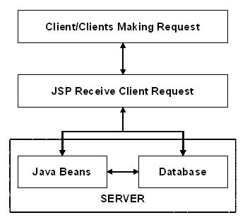

The above approach has the advantage of simplifying the process but its disadvantage is when the number of clients increases, the process becomes difficult to handle.

Dispatcher Approach:
This is also called N-tier approach, where the server side of the above architecture is divided into multiple tiers, using JSP as a controller, passing requests to Java Beans.

Step1:
Request from Client:
A JSP page has the extension as .jsp. The client request is made on the web browser by going to the .jsp extension JSP file.

Step2:
Request Sent To Server:
The request received from client (web browser) is sent to the server side.

Step3:
JSP Servlet Engine:
Since the extension of request made has .jsp extension, it indicates that it is a JSP file and therefore the web server passes the request received to the JSP Servlet Engine.

Step4:
Process of generating servlet:
JSP files are compiled by the JSP engine into a servlet. This step creates the .jsp file as a Java servlet source file.

Step5:
Process of making class file:
The source file from Step4 is compiled into a class file.

Step6:
Instantiation of Servlet:
The instantiation of servlet is performed using the init and service methods. In these methods, the jspInit () method is defined by the developer and the jspService method is generated by the JSP engine.
Step7:
Output HTML:
The request received from client is executed and the output is sent as HTML.

Step8:
Client Receives the Output:
The Client Receives the Output and thus the result namely the HTML gets displays in the client browser.

4.1.3 ORACLE Express Database 10g:
Oracle Application Express is a rapid Web application development tool for the Oracle database. Using only a Web browser and limited programming experience, you can develop professional applications that are both fast and secure. Thanks to built-in features such as user interface themes, navigational controls, form handlers, and flexible reports, Oracle Application Express accelerates the application development process.
From the end user’s perspective, the deployed applications require only a browser and access to an Oracle database running Application Express.

Oracle Application Express installs within Oracle Database Express Edition (Oracle
Database XE) and is comprised of data in tables and PL/SQL code.Whether you run the Oracle Application Express development environment or an application built using Oracle Application Express, the process is the same. Your browser sends a URL request that is translated into the appropriate Oracle Application Express PL/SQL call. After the database processes the PL/SQL, the results are relayed
back to your browser as HTML. This cycle happens each time you request or submit a page.
The application session state is managed in the database tables within Oracle Application Express. It does not use a dedicated database connection. Instead, each request is made through a separate database session, consuming minimal CPU resources.

Oracle Database Express Edition (Oracle Database XE) is a free, smaller-footprint
edition of Oracle Database. Oracle Database XE is easy to install and easy to manage.

With Oracle Database XE and related tools we can:

■ Administer the database
■ Create tables, views, and other database objects
■ Import, export, and view table data
■ Run queries and SQL scripts
This guide assumes that you are familiar with the following concepts and operations
described in Oracle Database Express Edition Getting Started Guide:
■ The Oracle Database XE user interface, including the system menu commands and
the database administration interface
■ Creating a database user
■ Installing and using SQL Developer, including creating database connections

4.1.3 BACK END TECHNOLOGY:

Client/Server:

In a client/server system, the server is a relatively large computer in a central location that manages a resource used by many people. When individuals need to use the resource, they connect over the network from their computers, or clients, to the server.

Examples of servers are: In client/server database architecture, the database files and DBMS software reside on a server. A communications component is provided so applications can run on separate clients and communicate to the database server over a network. The SQL Server communication component also allows communication between an application running on the server and SQL Server.

While SQL Server is designed to work as a server in a client/server network, it is also capable of working as a stand-alone database directly on the client. The scalability and ease-of-use features of SQL Server allow it to work efficiently on a client without consuming too many resources.

Structured Query Language (SQL):

To work with data in a database, you must use a set of commands and statements (language) defined by the DBMS software. There are several different languages that can be used with relational databases; the most common is SQL. Both the American N National Standards Institute (ANSI) and the International Standards Organization (ISO) have defined standards for SQL. Most modern DBMS products support the Entry Level of SQL-92, the latest SQL standard (published in 1992).

SQL Server Features
ORACLE database supports a set of features that result in the following benefits:

Ease of installation, deployment, and use
ORACLE database includes a set of administrative and development tools that improve your ability to install, deploy, manage, and use SQL Server across several sites.

Scalability:
The same database engine can be used across platforms ranging from laptop computers running Microsoft Windows® 95/98 to large, multiprocessor servers running Microsoft Windows NT®, Enterprise Edition.

Data warehousing:
Oracle Database includes tools for extracting and analyzing summary data for online analytical processing (OLAP). SQL Server also includes tools for visually designing databases and analyzing data using English-based questions.

System integration with other server software:

Databases
An Oracle database in consists of a collection of tables that contain data, and other objects, such as views, indexes, stored procedures, and triggers, defined to support activities performed with the data. The data stored in a database is usually related to a particular subject or process, such as inventory information for a manufacturing warehouse.SQL Server can support many databases, and each database can store either interrelated data or data unrelated to that in the other databases. For example, a server can have one database that stores personnel data and another that stores product-related data. Alternatively, one database can store current customer order data, and another; related database can store historical customer orders that are used for yearly reporting. Before you create a database, it is important to understand the parts of a database and how to design these parts to ensure that the database performs well after it is implemented.
Normalization theory:
Relations are to be normalized to avoid anomalies. In insert, update and delete operations. Normalization theory is built around the concept of normal forms. A relation is said to be in a particular form if it satisfies a certain specified set if constraints. To decide a suitable logical structure for given database design the concept of normalization, which are briefly described below.
- 1st Normal Form (1 N.F): A relation is said to be in 1 NF is and only if all unaligned domains contain values only. That is the fields of an n-set should have no group items and no repeating groups.
- 2nd Normal Form (2 N.F) : A relation is said to be in 2 NF is and only if it is in 1 NF and every non key attribute is fully dependent on primary key. This normal takes care of functional dependencies on non-key attributes.
- 3rd Normal Form (3 N.F) : A relation is said to be in 3 NF is and only if it is in 2 NF and every non key attribute is non transitively dependent on the primary key. This normal form avoids the transitive dependencies on the primary key.
- Boyce code Normal Form (BCNF): This is a stronger definition than that of NF. A relation is said to be in BCNF if and only if every determinant is a Candidate key.
- 4th Normal Form (4 NF) : A relation is said to be in 4 NF if and only if whenever there exists a multi valued dependency in a relation say A->->B then all of the relation are also functionally dependent on A(i.e. A->X for all attributes x of the relation.).
- 5th Normal Form (5 NF) OR Projection Join Normal Form (PJNF): A relation R is in 5 NF .if and only if every join dependency in R is implied by the candidate key on R . A relation can’t be non-loss split into two tables but can be split into three tables. This is called Join Dependency.
4.2 IMPLEMENTATION OF MODULES
Project Modules:
- Registration of vehicle
- Issue of no objection certificate
- Issue of certificate of vehicle fitness
- Issue of license to driver of motor vehicle
- Issue of permits
- Registration validation
- Driving license validity
- Permit validity
Registration of motor vehicle
Each and every vehicle have to get registered by their respective R.T.A’S to get permitted to travel on road’s. In order to get registered the owner’s have to provide few detail’s to be entered in the register form such as, vehicle owner name, owner address, engine number,color,month and year of manufactured, maker’s classification, type of vehicle, seating capacity, photo image, finger prints etc.

File =registrationvalidation.jsp
Description: Will validate the data for registration form.
Clause= if, while
while (rs.next())
{ REG_NO=rs.getString(1);
NAME= rs.getString(2);
AGE = rs.getString(3);
ADDR= rs.getString(4);
}
Method= getString();
Task of method=Will get data from data center
<%
if(RegNo.equals(""))
{
out.println("Please enter a Valid Registration Number");
}
%>

Issue of no objection certificate
After getting registered by their respective R.T.A’S which indeed gets transferred to the centralized database. Each and every vehicle by getting registered by their respective R.T.A’S in order to differentiate between the legalized transporter’s and non-legalized once.
By entering their unique registration details and also the registration validity issue and expiry detail’s one can get a no objection certificate. Here the registration validity can also be renewed.

File= NOCvalidation.jsp
Description: Will obtain data for NOC validity check
Clause= if, while
while (rs.next())
{
REG_NO = rs.getString(1);
NAME= rs.getString(2);
ADDR = rs.getString(3);
CLASS_OF_VEHICLE= rs.getString(4);
}
Method= getString();
Task of method=Will get data from data center
<%
if(REG_NO.equals(""))
{
out.println("Please enter a Valid Registration Number");
}
%>

Issue of certificate of fitness of transport vehicles
Based on the fitness of the vehicle they get a fitness certificate issued by the central government. In order to get a fitness certificate they have to satisfy few conditions’ provided by the government such as pollution check issued and expiry date, road tax details, insurance details such as issue and expiry and also the condition of the vehicle such as functioning of brakes and engine details etc.

File = fitnessvalidation.jsp
Description: Will check validity the fitness certificate
Clauses= if , while
while (rs.next())
{
RegNo = rs.getString(1);
name= rs.getString(2);
addr= rs.getString(3);
DOB=rs.getString(4);
}

Method= getString();
Task of method=Will get data from data center
<%
if(RegNo.equals(""))
{ out.println("Please enter a Valid Registration Number");
}
%>

Issue of license to driver of motor vehicle
On the basis of the details furnished by the furnisher such as address proof’s, personal details such as blood group, date of birth and application for type of vehicle or etc,insurance certificate,R.C,pollution check control of the vehicle already registered or etc.
Based on his/her details furnished the respective state R.T.A’S gives an unique license number to the details furnisher by crosschecking the driving skills.

File= licensevalidation.jsp
Description: Will obtain data for license validity check
Clause= if, while
while (rs.next())
{
LICENSE_ID= rs.getString(1);
NAME= rs.getString(2);
son_wife_daughter_of= rs.getString(3);
ADDR= rs.getString(4);
}
Method= getString();
Task of method=Will get data from data center
<%
if(LICENSE_ID.equals(""))
{
out.println("Please enter a Valid LICENSE Number");
}
%>

Issue of permits
In this module based on the details provided by the vehicle owner regarding the details of the license, vehicle pollution check certificate, vehicle fitness certificate, the permissions are given to stage carriers i.e. buses, for contract carriers(as taxes and contracted vehicles)and also for goods carriages permits.
Once a vehicle gets permission certificate then it can be allowed to travel across the states. After processing all the details R.T.A’S of respective states gives the validity tenure i.e issue and expiry dates and these details gets updated to the central database.
In case of goods carriers like trucks the weigh load is calculated before the movement from one state to another. Depending upon its vehicle structure the weight permits assigned. Whenever it is over weighed than suggested weight he should be penalized and the date and time of the penalty is maintained. And the different types of penalties are charged for offending the government rules.

File= Permitvalidation.jsp
Description: Will obtain data for permit validity check
Clause= if, while
while (rs.next())
{
REG_NO=rs.getString(1);
NAME= rs.getString(2);
ADDR= rs.getString(3);
}
Method= getString();
Task of method=Will get data from data center
<%
if(REG_NO.equals(""))

{
out.println("Please enter a Valid Registration Number");
}
%>

Registration validity
By the details provided by the vehicle owner during registration such as personal details and vehicle details, one can confirm that his/her registration is valid when we get a registration validity tenure i.e. issue and expiry date and by cross checking the present registration is within the tenure or not if else they are penalized based on the rules/sections provided according to the government act.
If they fail in the registration validity the owner can renew their validity at the R.T.A’S and the updates are again resembled at the central database.

File =registrationvalidation.jsp
Description: Will validate the data for registration form.
Clause= if, while
while (rs.next())
{ REG_NO=rs.getString(1);
NAME= rs.getString(2);
AGE = rs.getString(3);
ADDR= rs.getString(4);
}
Method= getString();
Task of method=Will get data from data center
<%
if(RegNo.equals(""))
{
out.println("Please enter a Valid Registration Number");
}
%>

Driving license validity
On furnishing the details for the license by the furnisher, on account of the legal documentation verification the R.T.A’S provide a validity of license for a particular tenure i.e. issue date and expiry date and a license number along with license holder name, address.
Based on the above details and also the validity of the license they are given permission to move across the check post of different states and once their validity duration gets expired it has to be renewed or else they are penalized.

File= licensevalidation.jsp
Description: Will obtain data for license validity check
Clause= if, while
while (rs.next())
{
LICENSE_ID= rs.getString(1);
NAME= rs.getString(2);
son_wife_daughter_of= rs.getString(3);
ADDR= rs.getString(4);
}
Method= getString();
Task of method=Will get data from data center
<%
if(LICENSE_ID.equals(""))
{
out.println("Please enter a Valid LICENSE Number");
}
%>

Permit validity
In this module, one has to enter the permit issued date and expiry date, the name of the permit holder, also the permit type whether it is a stage carrier or goods carrier or etc and also they cross check the permit weight of the respective permit details in order to cross check or verify whether he/she have got a valid permit or not or else they are fined according to their offence.

File= Permitvalidation.jsp
Description: Will obtain data for permit validity check
Clause= if, while
while (rs.next())
{
REG_NO=rs.getString(1);
NAME= rs.getString(2);
ADDR= rs.getString(3);
}
Method= getString();
Task of method=Will get data from data center
<%
if(REG_NO.equals(""))

{
out.println("Please enter a Valid Registration Number");
}
%>

CHAPTER-5
TESTING FORMS AND REPORTS

5.1 TESTING
5.1.1 Introduction to Testing
It is the stage of implementation, which ensures that system works accurately and effectively before the live operation Commences. It is a confirmation that all are correct and opportunity to show the users that the system must be tested with text data and show that the system will operate successfully and produce expected results under expected conditions.
Before implementation, the proposed system must be tested with raw data to ensure that the modules of the system work correctly and satisfactorily. The system must be tested with valid data to achieve its objective.
The purpose of system testing is to identify and correct errors in the candidate system. As important as this phase is, it is one that is frequently compromised. Typically, the project the schedule or the user is eager to go directly to conversion. Actually, testing is done to achieve the system goal. Testing is vital to the parts of the system are correct; the goal will be successfully achieved. Inadequate testing or non-testing leads to errors that may not appear until months later. This creates two problems:
- The time lag between the cause and appearance of the problem.
- The effect of system errors on files and records within the system. A small system error can conceivably exploded into much larger problem. Effectively early in the process translates directly into long term cost savings from a reduced number of errors.
Testing In Strategies

Unit Testing
A program represents the logical elements of a system. For a program to run satisfactorily, it must compile and test data correctly and tie in properly with other programs. Achieving an error free program is the responsibility of the programmer. Program testing checks for two types of errors: syntax and logical. Syntax error is a
program statement that violates one or more rules of the language in which it is written. An improperly defined field dimension or error messages generated by the computer. Logic error deals with incorrect data fields, out-of range items, and invalid combinations. Since diagnostics do not determine logic errors the programmer must examine the output carefully.
When a program is tested, the actual output is compared with the expected output. When there is a discrepancy the sequence of instructions must be traced to determine the problem the process is facilitated by breaking the program down into self-contained portions, each of which can be checked at certain key points. The idea is to compare program values against desk-calculated values to isolate the problem.

Unit testing has been performed on all the form modules. The syntax and logical errors have been corrected then and there. All the syntax errors have been rectified during compilation. The output has been tested with the manual.

Unit Test Consideration
The module “interface” is tested to ensure that information properly flows in and out of the programs unit under test. The local data structures are examined to ensure that the data stored temporarily maintains its integrity during all steps in an algorithm execution.
Boundary conditions are tested to ensure that the modules operated properly at boundaries established to limit or restrict processing. All independent paths through the control structures are exercised to ensure that all statements in modules have been executed at least once. Finally paths are tested.

UNIT TEST PERFORMANCE
Unit test is considered an equivalent to the coding step. After the source level code has been developed, reviewed and verified for correct syntax, unit test case begins, since a module is not stand-alone program. Drivers or stub software must be developed for each unit test.

INTEGRATION TESTING
Programs are invariably related to one another and interact in the total system. Each program is tested to see whether it conforms to related programs in the systems. Each portion of the system is tested against the entire module with both the test data and the live data before the entire system is tested as a whole.
Integration testing is systematic techniques for conducting the program structure. While at the same time conducting tests to uncover errors associated with the interfacing.
The objectives are to take unit tested modules and to built a program that has been dedicated by design.
There are two types of Integration steps,
Top down Integration.
Bottom up Integration

VALIDATION TESTING
The validation testing is performed for all the data in the system. The data are completely validated according to the companies requested and requirement.
Validation testing
In these testing, software is completely assembled as package, interfacing errors have been uncovered and correction testing begins after each one of the two possible conditions exists. They are,
The function or performance characteristic’s is confirm specification and are accepted. A deviation from the specification is uncovered and efficiency list is created.

OUTPUT TESTING
Various outputs have been generated by the system. The system generated output and the desk-calculated values have been compared. All the output is perfect as the company desires. It begins with low volumes of transactions based on live tone. The volume is increased until the maximum level for each transaction type is reached. The total system is also tested for recovery and fallback, after various major failures to ensure that no data are lost during the emergency time.

RESULTS
The Office Management has undergone the unit testing and it is ensured that the information properly flows in and out of the program. All the error-handling paths are tested and found that everything is working well.

    - Test Reports:
Test Reports:
Name of the Project: CENTRAL CHECKPOST COMPUTERISATION
Module Name: LOGIN FORM
Unit Name: Userid, password
Test Result: By entering the valid id number the employee’s i.e. admin of RTA or Check-post or even the employee can be able to log into the application and can be able to process with their respective jobs.
Test Plan:
Unit level/module form/integration
Test plan for: CENTRAL CHECKPOST COMPUTERISATION
Unit id: central check post computerization-Login form
Test Case id: Userid, password
Test Type: unit level/form level/integration level
Form Name: Login form
Base table: CCC
Purpose: Each and every employee is provide with a unique id with which they can be able get logged into the application.
Test Case Description: By entering a valid id number it cross checks from the database and then allow the employee to get accessed to the application or if not it describes he is not a valid user.
Ex-User id-varchar (20)
Constraint-primary key

Test Data:
S.No | Input specification | Expected result
1. | Column name:userid  Valid input: if the employee enters the valid id number in the form it just retrieves the details from the database whether he is a valid user or not and provides with their respective jobs.  Invalid input:  If the user enters the invalid number it just gets popped up with the message describing that he is not a valid user at all. | Valid input result: after crosschecking the details the valid users can able to carry out with their own respective jobs according to their roles.  Invalid input Result:  After cross checking the details from their respective databases if he is not a valid user then he is not allowed to get logged in to the application and pops with a message of invalid
2 | Column name: password  Valid input: if the employee enters the valid password in the form it just retrieves the details from the database whether he is a valid user or not and provides with their respective jobs.  Invalid input:  If the user enters the invalid password it just get popped up with the message describing that he is not a valid user. | Valid input result: after crosschecking the details the valid users can able to carry out with their own respective jobs according to their roles.  Invalid input Result:  After cross checking the details from their respective databases if he is not a valid user then he is not allowed to get logged in to the application and pops with a message of invalid

Test Completion Criteria:
When the expected result matches the actual result after performing the test .The test is considered to be complete.
Test Process:
Person Responsible for testing: YETENDRA
Person Responsible for solving defects: YETENDRA

Test Reports:
Name of the Project: CENTRAL CHECKPOST COMPUTERISATION
Module Name: REGISTRATION VALIDITY FORM
Unit Name: Regno, issuedate, expirydate, offense committed, penalty
Test Result: By entering the valid id number the employees i.e. admin of check-post employee can be able to log into the application and can be able to process with their respective RTA to know whether he has a valid reg number.
Test Plan:
Unit level/module form/integration
Test plan for: CENTRAL CHECKPOST COMPUTERISATION
Unit id: central check post computerization-Login form
Test Case id: Regno, issue date, expiry date, offense committed, penalty
Test Type: unit level/form level/integration level
Form Name: Registration validation form
Base table: Registration
Purpose: Each and every user are provide with an unique regno with which they can be able get an authority from respective RTA to run on road..
Test Case Description: By entering a valid regid number it cross checks from the database and then allow the employee to get accessed to the application or if not it describes he is not a valid user.
Ex-regno-varchar (20)
Constraint-primary key

Test Data:
S.No | Input specification | Expected result
1. | Column name: regno  Valid input: if the employee enters the valid id number in the form it just retrieves the details from the database whether he is a valid user or not and provides with their respective jobs.  Invalid input:  If the user enters the invalid number it just get popped up with the message describing that he is not a valid user at all and are penalized. | Valid input result: after crosschecking the details the valid users can able to carry out with their own respective jobs according to their roles.  Invalid input Result:  After cross checking the details from their respective databases if he is not a valid user then he is not allowed to get logged in to the application and pops with a message of invalid
2 | Column name: penalty  Valid input: if the employee gets the valid regno in the form it just retrieves the details from the database whether he is a valid user or not and provides with their respective jobs and allowed to move on.  Invalid input:  If the user enters the invalid password it just get popped up with the message describing that he is not a valid user and penalized with respect to offense committed. | Valid input result: after crosschecking the details the valid users can able to carry out with their own respective jobs according to their database.  Invalid input Result:  After cross checking the details from their respective databases if he is not a valid user then he is not allowed to get passed from check post and pops with a message of invalid and are penalized

Test Completion Criteria:
When the expected result matches the actual result after performing the test .The test is considered to be complete.
Test Process:
Person Responsible for testing: YETENDRA
Person Responsible for solving defects: YETENDRA

6. RESULT PRESENTATION AND DISCUSSION

It is the stage of implementation, which ensures that system works accurately and effectively before the live operation Commences. It is a confirmation that all are correct and opportunity to show the users that the system must be tested with text data and show that the system will operate successfully and produce expected results under expected conditions.
Before implementation, the proposed system must be tested with raw data to ensure that the modules of the system work correctly and satisfactorily. The system must be tested with valid data to achieve its objective.
The purpose of system testing is to identify and correct errors in the candidate system. As important as this phase is, one is frequently compromised. Typically, the project the schedule or the user is eager to go directly to conversion. Actually, testing is done to achieve the system goal. Testing is vital to the parts of the system are correct; the goal will be successfully achieved. Inadequate testing or non-testing leads to errors that may not appear until months later.

This creates two problems:
- The time lag between the cause and appearance of the problem.
- The effect of system errors on files and records within the system. A small system error can conceivably exploded into much larger problem. Effectively early in the process translates directly into long-term cost savings from a reduced number of errors.

ID | TEST CASE  NAME | INPUT | EXPECTED  OUTPUT | ACTUAL  OUTPUT | DESCRIPTION | RESULT
1. | Verify the registration process | Enter the respective details in the specified fields. | Registration should be successful | Registration successful | This is to verify the registration form for the student | Pass
2. | Insertion of mobile number in the field specified. | Enter only 9 digits of the mobile number | Invalid mobile number | Mobile number successfully updated | This is to verify that the mobile number is inserted correctly | Fail
3. | Insertion of mail id in the respective field. | Enter the valid mail id in the form of ***@gmail.com | Successfully updation of mail id | Mail id successfully updated | This is to verify that the mail id is inserted properly or not | Pass
4. | Login verification | Enter username and password | Redirect to the user home page | Redirected to the user home page | This is to verify that the user name and password specified are correct | Pass
5. | user login | Enter credentials of user | Redirect to download page | Redirected to download page | This is to verify that the fuser has login successfully | Pass
6. | Download | List the files to download | Click on the file to download | Download should be done | This is to verify that download has been completed | Pass
7. | Admin login | Enter credentials of user | File upload and price page | Redirected to file upload and price page | This is to verify that the login is successfully done | Pass
8. | Upload a file | Enter the price and choose the file | File should be uploaded successfully | Successfully uploaded | This is to verify that file is uploaded or not | Pass
9 | View user details | See the registerd users. | All the user details are displayed | users appear on the screen | This is to verify the functionality admin | Pass
10. | Logout | Click on the logout button | Should be directed to login page | Directed to the login page | This is to verify that logout button is working or not | Pass

6.2 SCREENSHOTS
Welcome page
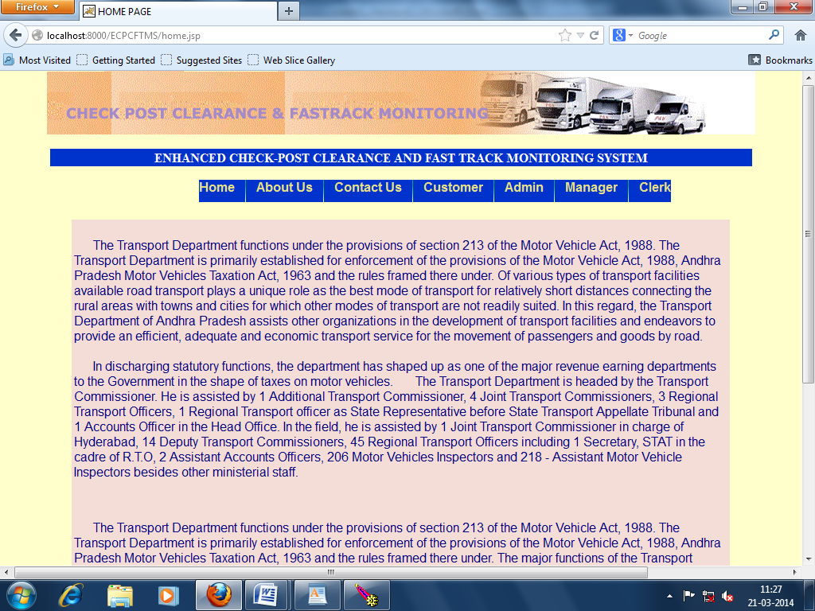

Contact us page
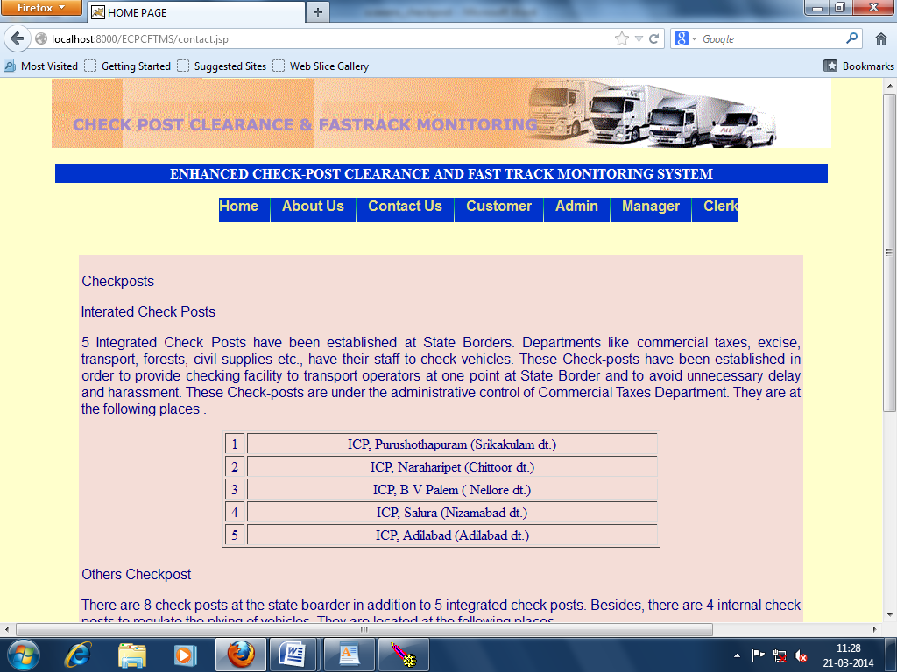
Admin can login
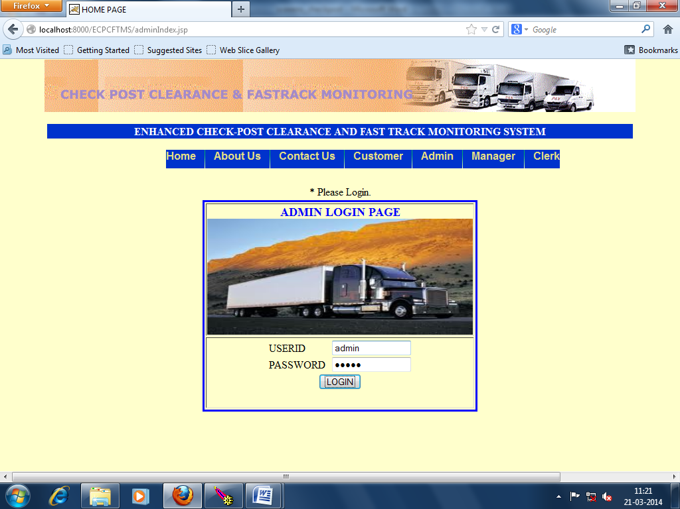
Customer login page
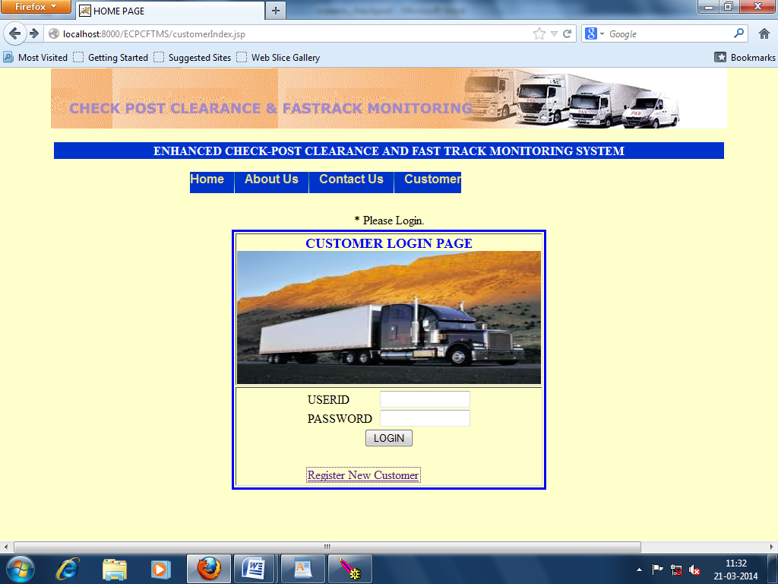
Customer Home Page
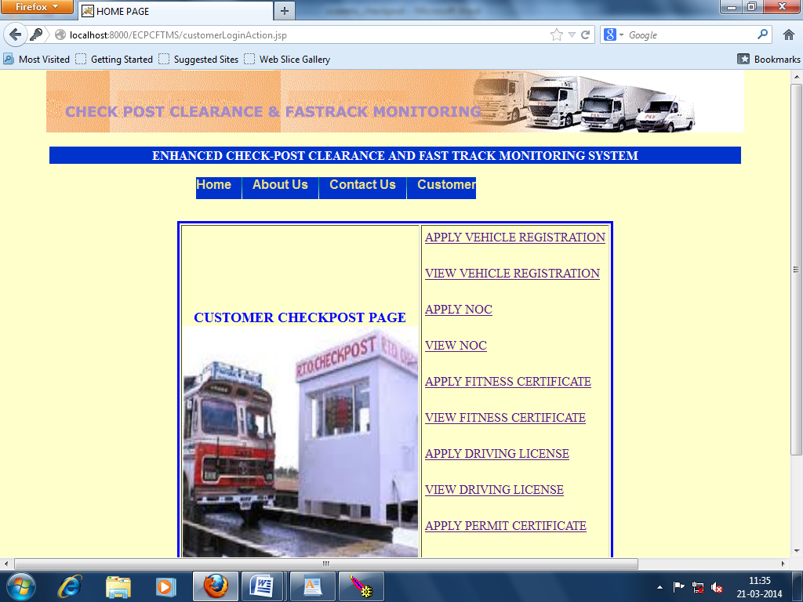
Manager transfer license
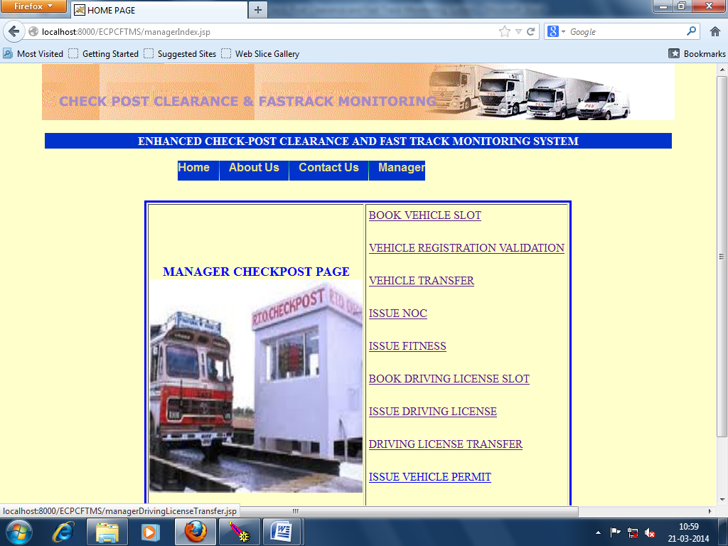
Check post clerk can login to application credentials given by admin
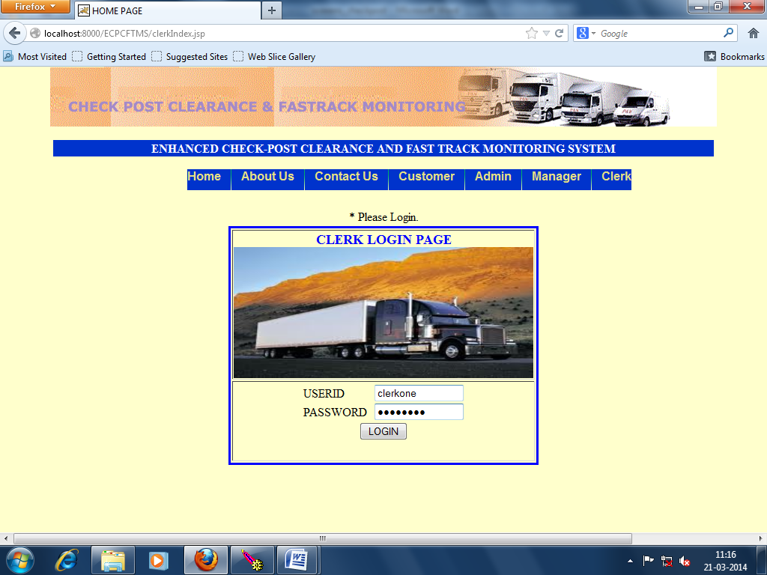

Home page of the clerk
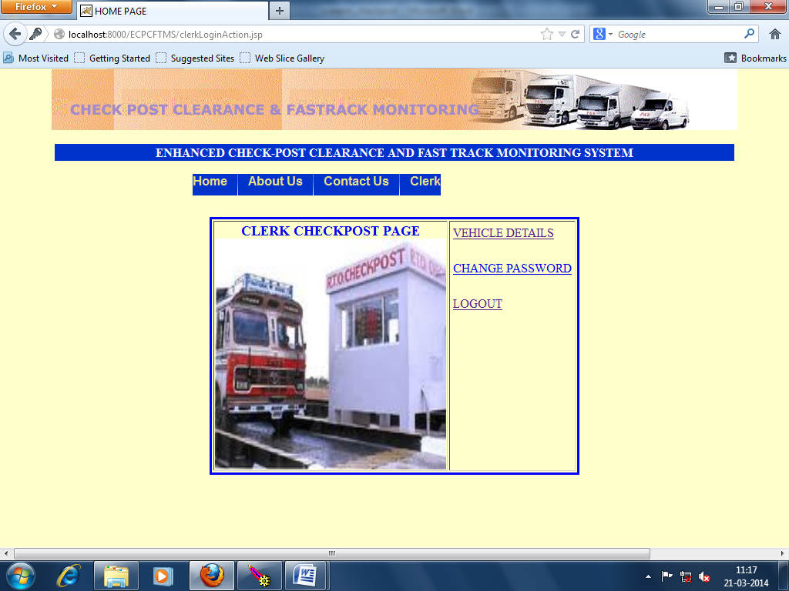
CHAPTER-7
CONCLUSION

The package was designed in such a way that future modifications can be done easily. The following conclusions can be deduced from the development of the project.

- Automation of the entire system improves the efficiency
- It provides a friendly graphical user interface which proves to be better when compared to the existing system.
- It gives appropriate access to the authorized users depending on their permissions.
- It effectively overcomes the delay in communications.
- Updating of information becomes so easier.
- System security, data security and reliability are the striking features.
- The System has adequate scope for modification in future if it is necessary.

This application avoids the manual work and the problems concern with it. It is an easy way to obtain the information regarding the various bugs information that are present in the projects.

Well I and my team members have worked hard in order to present an improved website better than the existing one’s regarding the information about the various activities. Still, we found out that the project can be done in a better way. Primarily, when we request information about a particular bug it just shows the project name, Bug id, bug name and no. of bugs available. So, after getting the information we can get access to the product company website just by a click on the product name.

For the next enhancement we can add the cam-reader for vehicle registration number scanner option. We can directly search to the particular bug from this site.

Future Enhancement:

It is not possible to develop a system that makes all the requirements of the user. User requirements keep changing as the system is being used. Some of the future enhancements that can be done to this system are:

- Provide a facility for check post people to scan vehicle photo and attach it to the registration number for future tracking.
- Provide a facility for the administrator to generate check-post wise crossed vehicle report.
- Based on the future security issues, security can be improved using emerging technologies like single sign-on
- As the technology emerges, it is possible to upgrade the system and can be adaptable to desired environment.

CHAPTER-8
BIBLIOGRAPHY

- 1.G.R. Bitran and R. Caldentey, "An Overview of Pricing Models for Revenue Management," Manufacturing and Service Operations Management, vol. 5, no. 3, pp. 203-209, 2003.
- N. Bruno and S. Chaudhuri, "An Online Approach to Physical Design Tuning," Proc. Int'l Conf. Data Eng. (ICDE '07), 2007.
- X.-R. Cao, H.-X. Shen, R. Milito, and P. Wirth, "Internet Pricing with a Game Theoretical Approach: Concepts and Examples," IEEE/ACM Trans. Networking, vol. 10, no. 2, pp. 208-216, Apr. 2002.
- C. Chen, M. Maheswaran, and M. Toulouse, "Supporting Co-Allocation In an Auctioning-Based Resource Allocator for Grid Systems," Proc. 16th Int'l Parallel and Distributed Processing Symp. (IPDPS '02), 2002.
- S. Choenni, H.M. Blanken, and T. Chang, "On the Selection of Secondary Indices In Relational Databases," Data and Knowledge Eng., vol. 11, no. 3, pp. 207-233, 1993.
- D. Dash, Y. Alagiannis, C. Maier, and A. Ailamaki, "Caching All Plans with One Call to the Optimizer," Proc. Self-Managing Database Systems (SMDB), 2010.
- D. Dash, V. Kantere, and A. Ailamaki, "An Economic Model for Self-Tuned Cloud Caching," Proc. IEEE Int'l Conf. Data Eng. (ICDE '09), 2009.
- C. Ernemann, V. Hamscher, and R. Yahyapour, "Economic Scheduling In Grid Computing," Proc. Eighth Int'l Workshop Job Scheduling Strategies for Parallel Processing (JSSPP '02), 2002.
- G. Gallego and G. van Ryzin, "Optimal Dynamic Pricing of Inventories with Stochastic Demand over Finite Horizons," Management Science,vol. 40, no. 8, pp. 999-1020, 1994.
- A. Ghose, V. Choudhary, T. Mukhopadhyay, and U. Rajan, "Dynamic Pricing: A Strategic Advantage for Electronic Retailers," Proc. Conf. Information Systems and Technology (CIST), 2003.
- I.E. Grossmann and Z. Kravanja, Large-Scale Optimization with Applications: Optimal Design and Control. Springer, 1997.
- M. Guay and T. Zhang, "Adaptive Extremum Seeking Control of Nonlinear Dynamic Systems with Parametric Uncertainty," Automatica, vol. 39, pp. 1283-1294, 2003.
- L. He and J. Walrand, "Pricing Differentiated Internet Services," Proc. IEEE INFOCOM, pp. 195-204, 2005.
- M. Kradolfer and D. Tombros, "Market-Based Workflow Management," Int'l J. Cooperative Information Systems, vol. 7, pp. 297-314, 1998.
- J. Li and R. Yahyapour, "Negotiation Model Supporting Co-Allocation for Grid Scheduling," Proc. IEEE/ACM Seventh Int'l Conf. Grid Computing, 2006.
- Z. Lin, S. Ramanathan, and H. Zhao, "Usage-Based Dynamic Pricing of Web Services for Optimizing Resource Allocation," Information Systems and E-Business Management, vol. 3, no. 3, pp. 221-242, 2005.
- T. Malik, X. Wang, R. Burns, D. Dash, and A. Ailamaki, "Automated Physical Design In Database Caches," Proc. Workshop Self-Managing Database Systems (SMDB), 2008.

